# AstroSage Analysis

**Objective questions**

1. **What is the total no. of tables present in the data?**
   1. Only single table

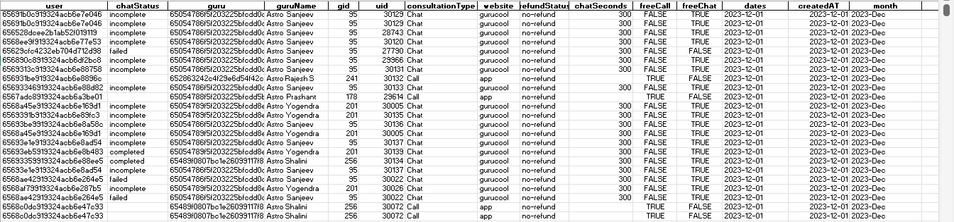

1. **What is the total no. of attributes present in the data?**
   1. Raw data- 35
   2. Cleaned -32
2. **The data consists of some inconsistent and missing values so ensure that the data used for further analysis is cleaned.**

The original dataset contained **35 columns**, but **not all fields were usable**. After an initial audit:

* 1. Columns such as _v, call_channels, and call_ivr_type were found to be either **inconsistent, irrelevant**, or **redundant** and were **removed** to streamline the analysis.
  2. This step helped reduce noise in the dataset and improve processing efficiency.

To extract **more meaningful insights** and enable time-based analysis, several **new derived columns were added**, including:

1. month – Extracted from the call date to enable monthly trend comparisons.
2. calling_month – A normalized text version (e.g., “2023-Dec”) for consistent labelling and grouping in visualizations.
3. calling_dates – Exact dates of calls to help with daily trend analysis.
4. call_timings (hr) – Extracted the hour from the timestamp to identify **peak activity windows** (e.g., for hourly distribution charts).
5. **What is the change in daily call volume day by day and also find the average of daily call volume?**
   1. change in daily call volume day by day – Kindly refer to **call volumes** worksheet in workbook
   2. average of daily call volume - 250.24

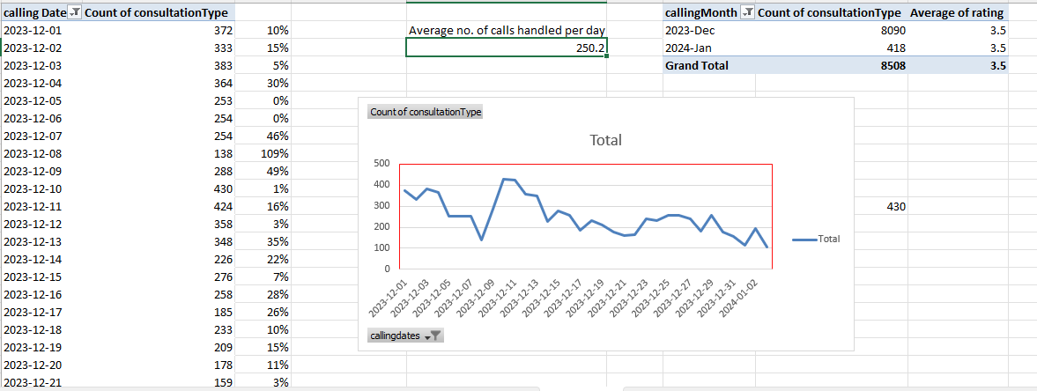

1. **Which months experienced the highest and lowest call volumes?-**

* 1. Highest – December
  2. Lowest- January

1. **What is the total operational cost for that month?**

* From the given data we can obtain that the amount which the astrologer is earning is the operational cost for the platform i.e., RS. 99,146

1. **What is the average number of calls handled per agent per day?**
   1. Kindly refer to **call by agent per day** worksheet in workbook
   2. Created a pivot table for different gurus and how many calls they have handled and in how many days they have handled these calls.
   3. Total calls / total unique dates / total unique gurus = avg. no. of calls handled per agent per day.

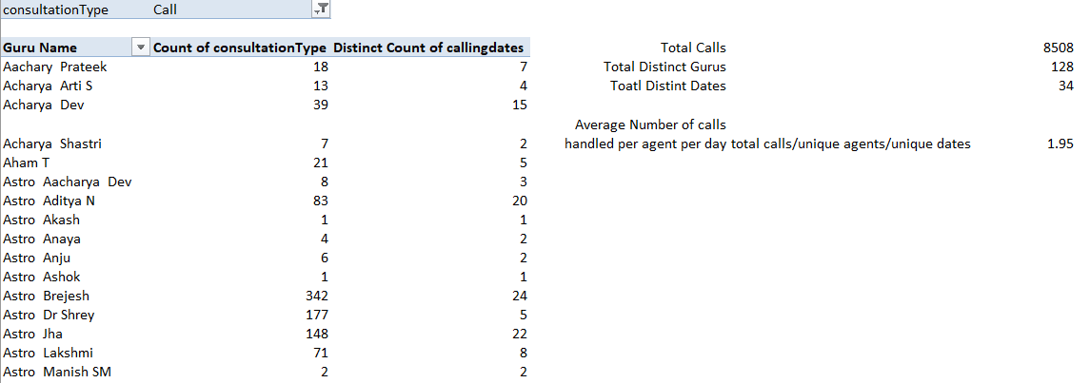

1. **How many repeat callers are there, and what percentage of total calls do they represent?**

Kindly refer to **Customer repeat rate** for further analysis

* 1. No. of repeat callers- 1275 (~35% of total callers)
  2. Total calls – 8508
  3. Total Repeat calls = 4735
  4. **Percentage of total calls they represent** – ~56%

|  |
| --- |
|  |

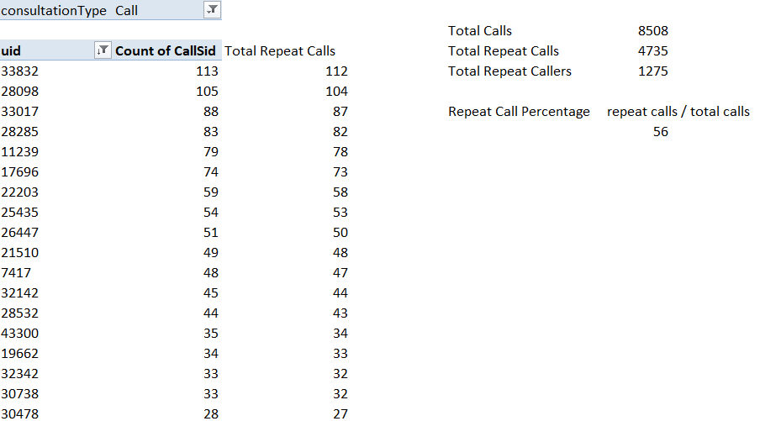

1. **What are the total sales generated by the call centre for each product category?**

**Revenue Earned/Generated**

* 1. Chat – 45494.7 Rs.
  2. Call – 168442 Rs.
  3. Public Live call and Complimentary: Negligible

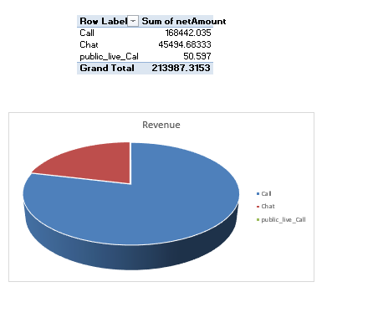

1. **How many calls were made for each user ID and guru ID?**
   1. Kindly refer to **Customer Repeat rate** in workbook for further analysis

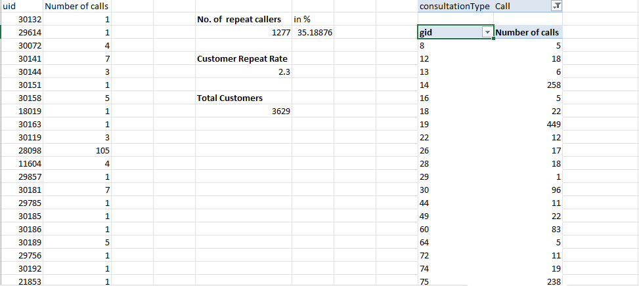

1. **What is the correlation between call duration and customer satisfaction?**
   1. Kindly refer to **rating and Call duration worksheet** in workbook

1. **Which guru have the highest and lowest customer satisfaction scores?**

|  |  |
| --- | --- |
| **Max Rating (8)** | **Min Rating (0)** |
| Astro Neetu | Astro Shalini |
| Tarot Rachana | Aachary Prateek |
| Astro Ashok | Astro Mahesh S |
| Astro Sujata S | Tarot Pooja |
| Astro Vishwajeet | Tarot Neha R |
| Tarot Rushali | Tarot Sunita |
| Astro Aditya Jhha | Dr. Balkrisna |
| Astro Manish SM | Tarot Ria |
| Astro Anil Shukla | Tarot Keshmin |
| Astro Pujaa Rai | Tarot Yashita |
| Astro Ankita C | Acharya Arti S |
| Tarot Gurpreet | Tarot Monika |
| Tarot Aritra C | Tarot Priya S |
| Tarot Shakti | Tarot Surbi |
| Astro Sushil S | Tarot Riya |
| Astro Neetu | Astro Gurdeep |
|  | Astro Yashi |
|  | Tarot Meera |
|  | Tarot Punam |
|  | Astro K Ojha |
|  | Astro Anaya |
|  | Tarot Ritika |
|  |  |

1. **What is the average customer satisfaction score by month?**
   1. December -2.9

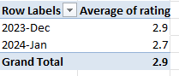

* 1. January – 2.7

1. **How many categorical columns are there in the data?**

Categorical columns — i.e., columns that typically contain a limited number of discrete values (like labels, categories, or statuses):

|  |
| --- |
| • user |
| • chatStatus |
| • guru |
| • guruName |
| • gid |
| • uid |
| • consultationType |
| • website |
| • refundStatus |
| • freeCall |
| • freeChat |
| • callStatus |
| • CallSid |
| • astrologerCallStatus |
| •userCallStatus |

***Subjective Questions:***

* 1. **Should the investment be used to hire more agents, improve training –––programs, or upgrade call center technology?**

**Key Observations:**

* Call has the highest earnings and net revenue (≈ 79% of total revenue).

* Chat dominates in terms of volume (≈70%), but revenue is driven by Call means more interactions are happening via chat, but it isn’t translating into high earnings.
* A **majority of users rated between 3–5** and **Guru rating distribution** also peaks around 3–5, meaning training could elevate it.
* **Very few high ratings (6–8)**, indicating room for service quality improvement.

* A considerable portion of calls/chats are marked incomplete, failed, or not answered **(~38%)** , only **~30%** completed which hints at possible inefficiency in handling calls or shortage of available/ready agents.
* 72% of usage is via dashboard, 28% via app, and 0% via gurucool.

**Recommendation Based on Analysis:**

1. **Improve Training Programs – Highest Impact**

Here's why:

🔧 Training Improves:

* Ratings (boosting customer satisfaction and potentially increasing usage).
* Call/chat completion rates (reducing incomplete/failed calls).
* Guru performance, which will lead to better conversion from chats and higher repeat users.

Hiring more agents might help volume but won’t fix quality. Upgrading technology may help in the long term but doesn’t directly address the service quality and low rating distribution.

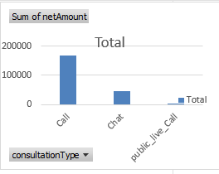

**2. Upgrade Call Center Technology – Medium-Term ROI**

* Since chat is high-volume and long-duration, tech upgrades like:
  + AI chatbots
  + Automated response templates
  + Intelligent routing  
    can drastically reduce manual workload and improve consistency.

This reduces agent burnout, ensures 24/7 availability, and maintains quality.

* Upgrade call center tech only if we’re experiencing system failures or lags, especially for “incomplete” calls.
* Optimize agent scheduling to improve response and reduce “not answered” cases.
* Use training focused on rating improvement, call handling, and user empathy.

Hiring without solving efficiency issues will increase fixed cost with limited benefit.

* 1. **What are the potential risks of each investment option (hiring, training, technology upgrades), and how can they be mitigated?**

Name the chart/spreadsheet function you will use for solving the problem?

**1. Hiring More Agents**

**Risks:**

* Increased Fixed Costs: More salaries without guaranteed increase in revenue.
* Underutilization: Volume charts show fluctuation (especially chat) — agents might sit idle during low-traffic periods.
* Training Lag: New agents need time to be productive, especially in a niche service like astrology.

**Mitigation:**

* Use demand forecasting (based on daily/weekly trends in dashboard) to hire part-time/flexible staff.
* Start with part-time or contract agents before full-scale onboarding.
* Implement a shift management system to balance load in peak and off-peak hours.
* Train new hires using recorded high-rated chat sessions for faster ramp-up.

**2. Improving Training Programs**

**Risks:**

* Training takes time to show impact on revenue or ratings.
* Time Off-Desk: Training takes agents away from active chat/call handling.
* No ROI If Misaligned: Training that doesn’t match real issues (e.g., tech skills vs. soft skills) won’t improve ratings.

**Mitigation:**

* Targeted Training: Base modules on actual data—like low-rated consultation types (e.g., “Chat” with a 2.68 avg. rating).
* Conduct micro-training modules during off-peak periods.
* Track post-training impact on ratings and duration to evaluate effectiveness and tie them to perks and bonuses.

**3. Technology Upgrades**

**Risks:**

* High Upfront Cost: Automation tools or CRMs are expensive.
* Agent Pushback: Existing agents may resist using new tools or processes.
* Downtime: Implementation may disrupt operations temporarily.

**Mitigation:**

* Start with low-cost tools (e.g., chat macros, auto-responses).
* Run a pilot test before full rollout.
* Provide hands-on training + support to encourage adoption.
  1. **How does AstroSage call center performance compare to that of AstroGuru in terms of average call volume, customer satisfaction, and agent performance?**

**Will you use any aggregation function or a visualization here to solve the problem?**

We’re not provided any kind of data for comparison with Astroguru.

* 1. **How can the call center improve its handling of peak call periods to ensure high customer satisfaction?**Mention the functionality which you will use for giving the suggestions, will it be any aggregated function or a visualization?

**Functionality Used:**

**Pivot Table**: Used to count calls per hour.

**Bar Chart**: Hourly call volume distribution.

**Excel Functions**:

COUNTIFS() for calculating call frequency.

AVERAGEIFS() for identifying satisfaction patterns.

**Analysis of Hourly Call Volume:**

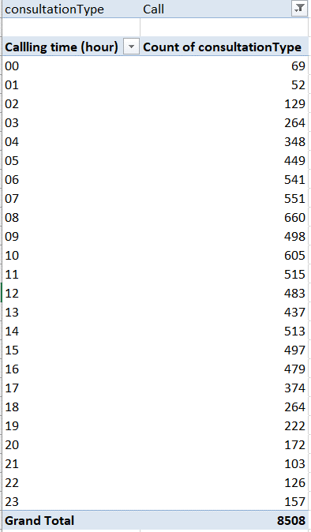

From the chart and pivot data:

**Peak Hours Identified**:

**08:00 to 14:00** are the busiest hours, especially **08:00 (660 calls)** and **10:00 (605 calls).**

**off-Peak Hours**:

**00:00–04:00** and **20:00–04:00** have minimal activity (less than 200 calls per hour).

**Average Call Load During Peak**:

On average, peak hours see **~500–660 calls/hour.**

**Recommendations for Improving Peak Hour Handling:**

1. **Redistribute Gurus Based on Hourly Call Demand**

Assign more gurus between **08:00–14:00**, aligned with hourly volume trends.

Use hourly call data from pivot to **map guru shifts accordingly**.

**2. Peak Hour Scheduling with Heatmap Support**

Build a heatmap using pivot tables with hour vs. call volume.

Schedule agents more heavily during **08:00–14:00**

3. **Staggered Shift Allocation**

Instead of flat shifts, **create dynamic, overlapping shifts:**

Shift 1: 07:00–13:00 (peak load starter)

Shift 2: 11:00–17:00 (mid-day peak)

Shift 3: 14:00–20:00 (wind-down)

4. **Implement Call-Back Queuing**

For high-traffic hours, allow users to **request a call-back** instead of waiting.

Reduces pressure and improves customer experience.

5. **Performance-Based Load Routing**

Route peak-hour calls to **top-performing gurus** (based on ratings and call resolution time).

Ensures best quality service during critical periods.

6. **Live Monitoring Dashboard**

**Track:**

Current queue length

Guru availability

Call drop rate

Enables **on-the-fly redistribution of active gurus.**

* 1. **Based on historical data, what strategic initiatives should be prioritized to improve overall efficiency and customer satisfaction?**

**Data Insights: Platform and Consultation-Type Based Ratings**

**Rating by Consultation Type**:



| **Consultation Type** | **Average Rating** |
| --- | --- |
| **Call** | **3.5** |
| **Chat** | 2.68 |
| **Complementary** | Lower & Volatile |
| **Public_live_Call** | Very low usage |

**Observation**: **Call** performs better than **Chat**, indicating real-time interaction leads to greater user satisfaction.

**Platform Usage & Potential**:

| **Platform** | **Usage %** | **Avg. Rating Trend** |
| --- | --- | --- |
| **Dashboard** | 72% | Highest |
| **App** | 28% | Moderate |
| **Gurucool** | 0% | Not used/Unknown |

**Observation**: Users interacting via **Dashboard** report higher satisfaction, while **App** and **Gurucool** need optimization.

**Strategic Initiatives to Prioritize**

1. **Improve Ratings by Channel and Platform**

**Issue**: Chat and app users give significantly lower ratings.

**Action**:

Train agents in effective **written communication.**

Implement **AI chat quality analysis** to flag poor sessions.

Enhance **app usability**—focus on speed, clarity, and minimal taps.

Investigate Gurucool’s failure: is it a broken flow or lack of visibility?

2. **Promote Call-Based Consultations**

**Why**: Calls have higher ratings **and** drive **79% of revenue.**

**Action**:

Push users to switch from chat to call using in-app nudges.

Offer **first-call free** or discounted call sessions.

Highlight "Top Rated Gurus available on call now" banners.

3. **Platform Optimization**

**Why**: Dashboard users report better satisfaction.

**Action**:

Conduct UX surveys on app and Gurucool.

Upgrade app UI and loading performance.

Consider **discontinuing or repurposing Gurucool** if recovery isn't viable.

4. **Train Underperforming Gurus Based on Channel Ratings**

**Why**: Guru rating distribution is skewed; few highly rated.

**Action**:

Use AVERAGEIFS() to map ratings by:

=AVERAGEIFS(RatingRange, ConsultationTypeRange, "Chat", PlatformRange, "App")

Identify gurus consistently underperforming on **chat + app** combo.

Run personalized feedback and training loops for these gurus.

5. **Peak Hour Load Balancing and Completion Optimization**

**Why**: High volume → more incomplete sessions → lower satisfaction.

**Action**:

Use call-hour pivot to **distribute gurus dynamically.**

Implement **real-time queue transparency** (show wait time).

Enable **smart routing** or call-backs for dropped sessions.

6. **Highlight and Benchmark Top Gurus**

**Why**: Top-10 Gurus list is a motivator and trust-builder.

**Action**:

Feature them on all platforms.

Promote them during high-volume periods.

Offer **incentives to others** to meet their benchmarks.

* 1. **What can be the key factors contributing to high customer satisfaction scores, and how can these be leveraged to improve overall performance?**

What is the basis for the suggestions? And mention how did you decide if the satisfaction score affect the ratings?

Basis for Suggestions – From the Dashboard:

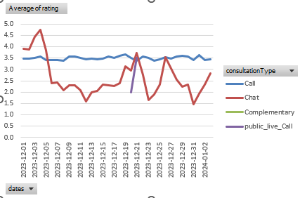

* Call consultations have a higher and more stable satisfaction rating compared to chats.
* Chat sessions, despite being the most frequent (≈70% of total), show fluctuating and often low average ratings.
* Public live calls and complementary calls have fewer data points but show moderately high satisfaction.

**1. Consultation Type – Complementary Sessions**

* Highest average rating: 4.5
* Likely due to lower pressure, expectation, or perceived value being higher because it’s free.

**Leverage Strategy:**

* Use complementary sessions as a lead funnel: Promote them to convert users into paid customers.
* Train other service types to emulate the complementary tone and approach (likely more casual, empathetic, and trust-building).

**2. High-Performing Gurus**

* A select few gurus have consistently higher ratings (Top 10 list).
* These individuals contribute significantly to user trust and satisfaction.

**Leverage Strategy:**

* Identify their best practices (e.g., tone, clarity, session structure).
* Use recordings or reviews to train lower-rated gurus.
* Offer incentives or badges to motivate others to reach top-tier performance.

**3. Shorter, Focused Duration**

* Charts show that complementary, public_live_call and chat have short durations.

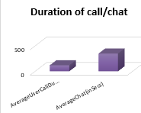

* While chat is lower-rated, a balance between brief but impactful sessions may appeal to users.

**Leverage Strategy:**

* Optimize sessions to be concisebut clear, especially for repeat or follow-up queries.
* Introduce session summaries or follow-up messages for clarity and added value.

**4. Platform Experience – Dashboard Usage**

* 72% of usage happens on the dashboard; high familiarity or better UX might enhance user comfort and satisfaction.

**Leverage Strategy:**

* Mirror dashboard UX features across app and other platforms.
* Identify features that aid satisfaction (e.g., smoother navigation, better call/chat access) and replicate them universally.

1. **Time of Interaction**

* From “Change in Daily Rating” graph, higher ratings often correspond with mid-week or off-peak hours.

**Leverage Strategy:**

* Offer incentives to book during non-peak hours (better service, faster response).
* Allocate high-performing gurus during predictable low-rating days to balance quality.

1. **Volume vs. Quality:**
   * Chat’s high volume may be diluting quality—overloaded agents, copy-pasted responses, or delayed replies.

**Leverage Strategy:**

* + Reduce chat overload by using historical volume data to reallocate agent resources dynamically.
  1. **How should the call center balance the workload among agents to ensure optimal performance and avoid burnout?**

Mention your approach and spreadsheet function for the answer?



**Note: to view pivot table for non-uniform distribution of workload, kindly refer to rating and call duration.**

**The snippet (part of pivot table) attached shows the non-uniform distribution of workload with some gurus taking no calls to with some gurus taking calls for an average of ~800 mins.**

**Approach:**

- Use Average Call Duration (118.78 mins) and Total Connections (28,027) to estimate workload.

- Monitor total calls (8,508) and chats (19,514) to allocate agents efficiently across modes.

- Focus on peak days (as seen in the time-series call/chat volume graph) to add more staff dynamically.

**Spreadsheet Function:**

* Use =AVERAGEIFS() to calculate average duration per agent per day.
* Use =IF(total_calls/agents > threshold, "Add Staff", "Normal") for workload alerts.
* Conditional formatting for red flags on overburdened agents (e.g., >6 hours/day of call time).

**How to balance workloads:**

* Forecast call/chat volumes per hour/day and align shifts accordingly.
* Route complex calls to experienced gurus; direct simpler queries to juniors.
* Set time targets per session type.
* Automatically flag sessions exceeding thresholds for review.
* Use auto-closure systems in chat to reduce idle wait time for agents.
* Allow agents to mark themselves as needing a break (automated system restricts new allocation for X mins).
* Ensure mandatory short breaks after fixed call/chat durations (e.g., 10 minutes after every 90 minutes).
* Introduce a fair rotation for peak shifts.
* Use point-based shift credit (e.g., 2 credits for weekends, 1 for weekdays) to equalize load over time.
* Use KPI dashboards to signal when to adjust or reduce an agent’s workload.
  1. **What new technologies or tools could be implemented to enhance call center operations and customer service?**

**1. AI-Powered Chatbots & Voice Assistants**

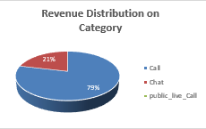

**Why:**

* Chat channel has 70% of volume but low ratings (2.68) and completion issues.
* Calls are more effective for revenue and ratings.

**Tool Suggestion:**

* Dialogflow (by Google), Azure Bot Services, or Yellow.ai.

**Benefits:**

* Handles FAQs, triage queries, and user routing.
* Frees up agents for high-value interactions.
* Can guide users from chat to call escalation automatically.

**2. Intelligent Call Routing (ICR)**

**Why:**

* Some gurus are top-rated; others are pulling down overall satisfaction.
* Manual routing may not match user needs to agent strengths.

**Tool Suggestion:**

* Genesys Cloud, Five9, or Zendesk Talk.

**Benefits:**

* Routes based on user intent, past behavior, and agent performance.
* Reduces handling time and improves satisfaction by first contact resolution.

**3. Real-Time Agent Monitoring & Workload Dashboards**

**Why:**

* High percentage of incomplete or pending sessions.
* Burnout risk if agents are overloaded during peaks.

**Tool Suggestion:**

* LiveAgent, Freshdesk, or a custom Power BI / Tableau dashboard integrated with backend data.

**Benefits:**

* Monitors active load, breaks, idle time.
* Helps in real-time reallocation of agents during surges.

**4. Conversational Analytics (Speech & Chat Insights)**

**Why:**

* Current ratings don't tell why a session was poor.
* No insights into tone, keywords, or sentiment during calls/chats.

**Tool Suggestion:**

* Observe.ai, CallMiner Eureka, Talkdesk Speech Analytics.

**Benefits:**

* Tracks emotion, tone, and sentiment in real time.
* Flags potential service failures or training needs immediately.

**5. Automated Feedback Collection & Tagging**

**Why:**

* We have feedback data but likely not segmented or analyzed deeply.

**Tool Suggestion:**

* Typeform, Qualtrics, or native feedback forms with NLP analysis via Python.

**Benefits:**

* Collects instant feedback post-session.
* Auto-tags feedback sentiment and maps to guru/session/channel.

**6. Robotic Process Automation (RPA)**

**Why:**

* Agents spend time on repetitive tasks: booking, follow-ups, note-taking.

**Tool Suggestion:**

* UiPath, Automation Anywhere, or Power Automate.

**Benefits:**

* Automates backend workflows like sending confirmations, updating CRM, scheduling follow-ups.
* Reduces average handling time (AHT).

**7. AI-Based Guru Coaching Assistants**

**Why:**

* Wide variation in ratings among gurus; need personalized development.

**Tool Suggestion:**

* Creyos, Docebo AI Coach, or internal tools using LLM-based scoring.

**Benefits:**

* Analyses agent transcripts/calls and provides **personalized feedback**.
* Suggests improvements in tone, timing, empathy, and call handling.

**8. Omnichannel Integration Platforms**

**Why:**

* Dashboard shows distinct user behaviour across dashboard, app, and Gurucool (0% usage).

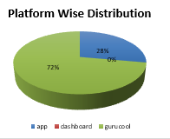

**Tool Suggestion:**

* Twilio Flex, Freshdesk Omnichannel, Zoho Desk.

**Benefits:**

* Manages all channels (chat, call, app, web) from a single dashboard.
* Enables seamless switching between channels with session history intact.
  1. **What metrics should be included in the final dashboard to provide a comprehensive view of call center performance and guide investment decisions?**

**A. Operational Metrics (Volume & Flow)**

| **Metric** | **Why It Matters** |
| --- | --- |
| Total Calls / Chats Received | Tracks demand trend across channels |
| Completed vs. Incomplete Sessions | Highlights handling efficiency and issues |
| Average Handling Time (AHT) | Assesses efficiency per interaction |
| Peak Hour Load | Identifies need for shift optimization |
| Abandonment Rate | Shows user frustration before connection |

**B. Customer Satisfaction & Quality Metrics**

| **Metric** | **Why It Matters** |
| --- | --- |
| Average Customer Rating (per channel guru) | Core indicator of service quality |
| First Contact Resolution (FCR) | Reduces repeat load; directly tied to satisfaction |
| Post-Session Feedback Rate | Ensures rating data is valid & representative |
| Sentiment Score (AI-driven) | Adds context from call/chat transcript analysis |

**C. Financial & ROI Metrics**

| **Metric** | **Why It Matters** |
| --- | --- |
| Revenue by Channel (Call vs. Chat) | Measures ROI by service type |
| Revenue per Session / per Guru | Tracks profitability at micro level |
| Cost per Interaction | Useful for comparing staffing vs. tech investment |
| Conversion Rate (Free to Paid) | Especially important if using free consultations |
| Repeat User Rate | Indicator of trust, stickiness, and loyalty |

**D. Agent / Guru Performance Metrics**

| **Metric** | **Why It Matters** |
| --- | --- |
| Average Rating per Guru | Identifies top/low performers |
| Utilization Rate | Balances workload distribution |
| Sessions per Day / per Guru | Helps plan capacity and hiring decisions |
| Burnout Risk Flag | From high load + falling ratings |
| Response Time | Speed matters, especially in chat |

**E. Service-Level KPIs**

| **Metric** | **Why It Matters** |
| --- | --- |
| SLA Compliance Rate (e.g. answered in 30s) | Evaluates promptness & standards |
| Escalation Rate | Tracks cases that needed supervisor intervention |
| Queue Time (avg/max) | Long waits lower satisfaction |
| Missed / Failed Session Reasons | Classifies drop causes: agent busy, tech issue… |

**F. Strategic Summary Metrics**

| **Metric** | **Why It Matters** |
| --- | --- |
| Agent Scorecard (rating + volume + conversion) | 360° view of agent productivity |
| Channel Efficiency Index (Revenue / Time) | Helps justify investments per channel |
| Trend Line for Ratings/Volume | Tracks long-term progress and seasonality |

**Metrics That Directly Guide Investment Decisions**

| **Investment Decision** | **Driving Metric** |
| --- | --- |
| Hire More Agents | Incomplete session %, Utilization, Peak Load |
| Improve Training | Rating gaps, Escalation rate, FCR, CSAT drops |
| Upgrade Technology (Chatbot, Routing, etc.) | AHT, Wait Time, Abandonment, Cost per Interaction |
| Expand Profitable Channels (e.g. Call) | Revenue/Session, Conversion Rate, Channel ROI |

* 1. **How would you allocate a 1 crore rupee investment to optimize operational efficiency, enhance customer satisfaction, and boost profitability, and what analysis-based recommendations would you offer to support this?**

| **Investment Area** | **Budget (₹ Lakhs)** | **% Allocation** | **Rationale** |
| --- | --- | --- | --- |
| 1. Hire & Train Additional Agents | ₹25 L | 25% | Reduce incomplete sessions, handle peak loads, balance workload |
| 2. AI Chatbot & Smart Routing | ₹20 L | 20% | Offload repetitive chats, improve chat experience (currently low rated) |
| 3. Call Center Tech Upgrade | ₹15 L | 15% | Faster response, auto-assign sessions, better CRM integration |
| 4. Guru Coaching & Quality Tools | ₹10 L | 10% | Personalized training to uplift low performers and boost CSAT |
| 5. Real-Time Analytics Dashboard | ₹10 L | 10% | Enable live monitoring, smarter decision-making |
| 6. Customer Feedback Analytics | ₹5 L | 5% | Extract insights from qualitative ratings and chats |
| 7. Wellness & Retention Programs | ₹5 L | 5% | Reduce burnout, maintain morale of top agents |
| 8. Contingency & Pilot Projects | ₹10 L | 10% | Test new channels (e.g., WhatsApp/voice AI), R&D |

**Analysis-Based Recommendations Supporting This Plan**

**1. Hire & Train More Agents (₹25L)**

**Dashboard Insight:**

* High number of incomplete or pending sessions, especially during peak times.
* Some agents are overutilized, risking burnout.

**Impact:**

* Improved session completion rate.
* Reduced wait time & abandonment.
* Balanced load = higher quality service and sustainable agent performance.

**2. AI Chatbot & Smart Routing (₹20L)**

**Dashboard Insight:**

* Chat channel = 70% of volume but low ratings (~2.68).
* Overload from basic repetitive queries.

**Solution:**

* Implement AI chatbot to triage chats.
* Use smart routing to connect high-value users to top agents.

**Impact:**

* Reduced agent strain.
* Shorter response time.
* Improved conversion from free to paid sessions.

**3. Call Center Tech Upgrade (₹15L)**

**Issues Identified:**

* Manual tracking, long wait times, poor escalations.

**Invest in:**

* Advanced CRM integration, auto-assignment, and multi-channel visibility.

**Impact:**

* Higher first contact resolution (FCR).
* Less time wasted on switching tools → lower AHT (Average Handling Time).

**4. Guru Performance Coaching (₹10L)**

**Dashboard Insight:**

* Some gurus consistently get poor feedback.
* High variance in user satisfaction across agents.

**Plan:**

* Use AI-driven tools to analyze transcripts, suggest personalized improvements.
* Periodic training workshops + roleplays.

**Impact:**

* Elevates CSAT scores and guru performance.
* Lowers escalation & dropout rates.

**5. Real-Time KPI Dashboard (₹10L)**

**Gaps Identified:**

* No live view of wait time, queue, session health.

**Investment in:**

* Live dashboards (Power BI/Tableau or custom tool) showing:
  + Agent load
  + Session status
  + Rating heatmaps

**Impact:**

* Managers can take real-time corrective action.
* Prevents overflow and service bottlenecks.

**6. Feedback Text Analytics (₹5L)**

**Observation:**

* Feedback is numeric but not text-mined.
* No visibility into “why” ratings are low**.**

**Solution:**

* Apply NLP on post-session feedback.
* Group by themes (e.g., rudeness, long wait, unclear guidance).

**Impact:**

* Faster root cause analysis.
* Clear input for process redesign or agent training.

**7. Agent Wellness & Retention (₹5L)**

**Why Needed:**

* Top-performing agents risk burnout.
* Retaining them reduces future training cost.

**Use Funds For:**

* Incentives, wellness breaks, mental health sessions.
* “Top Guru” rewards based on combined scorecard.

**Impact:**

* Better agent morale, retention, and consistent quality.

**8. Pilot Innovations / Contingency (₹10L)**

**Why Reserve This:**

* Test channels like WhatsApp, Telegram, or voice-based IVR.
* Or cover unforeseen spikes in load (festive months).

**Outcome:**

* Becomes R&D fund to future-proof service.